NETWORKWALKS WEEK 2 CYBERSECURITY ASSESSMENT

FOOTPRINTING, ENUMERATION, GHDB & NETWORK SCANNING
Prepared by: Modiri Sepakwa
Program/Batch: B082 — Networkwalks

Assessment Period: September 2026

Modules Covered
- W2-PM1 — Multiple Kali Linux Tools
- W2-PM5 — Zenmap / Network Scanning
- W2-PM2 - GHDB / Google Dork Exercises

Assessment Scope
Target | Type | Authorization
networkwalks.com | Public-facing domain reconnaissance | Written permission obtained
10.53.183.0/24 | Personal/local LAN host discovery | Personally controlled network
GHDB examples | Training/exercise material | Educational exercise; not represented as authorized penetration testing

EXECUTIVE SUMMARY
This report documents cybersecurity practical exercises conducted during Week 2 of the Networkwalks cybersecurity internship program.
The assessment activities covered three primary areas:
- Footprinting and reconnaissance against the authorized networkwalks.com domain.
- GHDB / Google Hacking Database exercises involving search-engine reconnaissance techniques.
- Network discovery and scanning against the assessor's own local network using Zenmap/Nmap.
The reconnaissance activity used several Kali Linux tools to collect publicly observable information about networkwalks.com, including domain registration information, DNS infrastructure, web technologies, HTTP headers, and Web Application Firewall identification.
The following tools were used during the footprinting activity:
- WHOIS
- WhatWeb
- Nslookup
- cURL
- WAFW00F
- DNSRecon
The assessment identified several externally observable characteristics of the website and its supporting infrastructure. These included WordPress and WordPress Download Manager fingerprinting, the public server IP address 192.232.216.135, publicly observable DNS records, HTTP response information, and identification of ModSecurity as a Web Application Firewall.
The second practical involved GHDB exercises demonstrating how search-engine operators can locate publicly indexed systems or files matching particular search patterns. These entries are documented as training exercises and are not represented as vulnerabilities discovered against Networkwalks or as systems that were independently authorized and tested.
For the local network assessment, the assessor's primary workstation was running CachyOS Linux rather than the Windows operating system used in the original practical instructions. The equivalent Linux commands were used to identify the local IP address and subnet.
The workstation was identified as:
- Local IP: 10.53.183.196
- Subnet: 10.53.183.0/24
- Interface: wlan0
The latest Nmap host-discovery scan identified two live hosts:
- 10.53.183.177
- 10.53.183.196 — the scanning workstation
The result differs from an earlier scan that identified a different number of live hosts. This is expected in a dynamic LAN environment because devices may connect, disconnect, sleep, change wireless state, or become temporarily unreachable.
No exploitation or unauthorized access was performed as part of the documented footprinting and network-discovery activities.

LIABILITY DISCLAIMER
All activities documented in this report were conducted for educational, research, and cybersecurity training purposes.
Testing was restricted to systems for which appropriate authorization had been obtained or systems and networks personally controlled by the assessor.
The information contained in this report is intended for authorized cybersecurity education and professional development.
Unauthorized access, scanning, enumeration, exploitation, credential use, or other security testing against systems without appropriate authorization may violate applicable laws and organizational policies.
The assessor accepts responsibility for ensuring that future testing activities remain within the defined scope and authorization of the engagement.
The GHDB examples included in this report are documented as educational exercises. Their inclusion does not constitute authorization to access, exploit, monitor, or otherwise interact with the third-party systems represented by those examples.

ASSESSMENT OBJECTIVES
The objectives of the practical exercises were to demonstrate the ability to:
- Perform passive and active reconnaissance.
- Identify publicly available domain information.
- Identify web technologies and application components.
- Resolve domain names to IP addresses.
- Inspect HTTP response headers.
- Identify Web Application Firewall technology.
- Enumerate DNS records.
- Understand Google Hacking Database/search-engine reconnaissance techniques.
- Identify the local IP address and subnet.
- Discover live hosts on an authorized local network.
- Identify IP and MAC address information where available.
- Generate a network topology using Zenmap.
- Document cybersecurity findings professionally.
- Assess the potential security significance of information discovered during reconnaissance.

SCOPE AND RULES OF ENGAGEMENT

Authorized Scope
The primary authorized targets were:

External Target
Domain:
networkwalks.com
The practical documentation indicates that written permission had been obtained for the Networkwalks assessment.

Internal / Local Target
Network:
10.53.183.0/24
This represented the assessor's own local LAN.

GHDB Training Material
The GHDB material supplied for the exercise contained examples involving publicly indexed webcams and directory listings.
These entries are treated strictly as educational examples and are not classified as findings against Networkwalks.

TESTING ENVIRONMENT

Operating Systems

Reconnaissance Environment
Kali Linux
Used for:
- WHOIS
- WhatWeb
- Nslookup
- cURL
- WAFW00F
- DNSRecon

Network Scanning Environment
CachyOS Linux
The original training instructions referenced Windows CMD and Zenmap. Because the assessor uses CachyOS as the primary operating system, Linux networking commands and Nmap were used to obtain the equivalent information.

TOOLS USED
Tool | Phase | Purpose
WHOIS | Reconnaissance | Domain registration and registrar information
WhatWeb | Reconnaissance | Web technology fingerprinting
Nslookup | Reconnaissance | DNS resolution
cURL | Reconnaissance | HTTP response-header inspection
WAFW00F | Reconnaissance | WAF identification
DNSRecon | Reconnaissance | DNS record enumeration
Google / GHDB techniques | Enumeration | Search-engine reconnaissance
Nmap | Network Scanning | Host discovery
Zenmap | Network Scanning | Graphical Nmap interface and topology
ip addr | Local Discovery | Local IP/interface information

METHODOLOGY
The assessment followed a reconnaissance-to-discovery workflow.

Phase 1 — Reconnaissance
Publicly available information relating to the authorized domain was collected using standard reconnaissance utilities.
The process included:
- Domain registration enumeration.
- Web technology fingerprinting.
- DNS resolution.
- HTTP response inspection.
- WAF detection.
- DNS record enumeration.

Phase 2 — Network Discovery
The local network was identified from the Linux workstation's interface configuration.
The identified subnet was then subjected to host discovery using Nmap/Zenmap.
The assessment was intentionally limited to discovery rather than exploitation.

MODULE 1 — FOOTPRINTING & RECONNAISSANCE

8.1 WHOIS Enumeration

Command
whois networkwalks.com

Key Observations
The WHOIS results identified:
- Domain: networkwalks.com
- Registrar: GoDaddy.com, LLC
- Creation date: 6 November 2019
- Registry expiration: November 2027
- Name servers including:
  - NS6135.HOSTGATOR.COM
  - NS6136.HOSTGATOR.COM
- DNSSEC status: unsigned
- Registrant information protected through a privacy service.

Security Significance
WHOIS information can provide useful context during reconnaissance.
Name-server information can assist an assessor in understanding the organization's DNS and hosting infrastructure.
Registrant privacy protection reduces the amount of direct personal information exposed through the registration record.

Assessment
Observation: Public domain-registration information is available.
Potential Impact: Low
This information is not itself a vulnerability. It is primarily useful for infrastructure profiling.

WHATWEB FINGERPRINTING

Command
whatweb networkwalks.com

Key Findings
WhatWeb identified several technologies and characteristics associated with the website.
Observed information included:
- Apache
- WordPress
- WordPress Download Manager
- jQuery 3.7.1
- Bootstrap-related information
- Google Tag Manager
- HTML5
- IP address 192.232.216.135
- Website title: Networkwalks Academy
- WordPress version information reported by WhatWeb
- WordPress Download Manager version 3.3.58

Security Significance
Technology fingerprinting can provide attackers or security assessors with information about the software stack.
Version information may assist authorized assessors in determining whether installed components correspond to known security advisories.
However, identification of software does not establish that the software is vulnerable.

Assessment
Observation: Web application technologies and component information are externally fingerprintable.
Potential Impact: Medium
Recommended Action: Review publicly exposed technology information and ensure that CMS and plugins remain appropriately patched.

DNS ENUMERATION WITH NSLOOKUP

Command
nslookup networkwalks.com

Observed DNS Server
8.8.8.8

Result
Name: networkwalks.com
Address: 192.232.216.135

Security Significance
DNS resolution revealed the public IP address associated with the domain.
This provides an assessor with information about the network endpoint hosting the web service.

Assessment
Observation: Domain resolves to 192.232.216.135.
Potential Impact: Low
The exposure of a public web server's IP address is normal for Internet-facing infrastructure and is not automatically a vulnerability.

HTTP HEADER ANALYSIS

Command
curl -I https://networkwalks.com

Response
The server returned:
HTTP/2 200
The response included headers associated with:
- Apache
- WordPress
- caching infrastructure
- referrer policy
- permissions policy
- cookies
- WordPress REST API references.

Notable Observation
The response included a WordPress REST API reference:
/wp-json/
The HTTP response also identified the server as Apache.

Security Significance
HTTP headers may disclose information about:
- web-server technology
- application architecture
- caching infrastructure
- application endpoints
- security policies.
The presence of /wp-json/ is normal for WordPress installations and does not independently constitute a vulnerability.

Assessment
Observation: HTTP response exposes technical application information.
Potential Impact: Low
Recommended Action: Review headers and exposed metadata to ensure that unnecessary technical information is minimized.

WAF DETECTION

Command
wafw00f networkwalks.com

Result
WAFW00F reported:
The site https://networkwalks.com is behind ModSecurity (SpiderLabs) WAF.

Security Significance
The result indicates that ModSecurity was fingerprinted as a Web Application Firewall.
A WAF can provide an additional security control between Internet clients and the web application.

Assessment
Observation: ModSecurity was detected.
Potential Impact: Low
The existence of a WAF should not be interpreted as proof that the application is secure. WAF configuration, rules, exclusions, application security, and patching still require independent review.
DNSRECON ENUMERATION

Command
dnsrecon -d networkwalks.com

Key Findings
The enumeration identified:

SOA
ns6135.hostgator.com
50.87.144.87

Name Servers
ns6136.hostgator.com
192.232.216.131
ns6135.hostgator.com
50.87.144.87
Mail Server
mail.networkwalks.com
192.232.216.135
A Record
networkwalks.com
192.232.216.135
TXT Records
The enumeration identified a Google site-verification record and an SPF record.
The SPF record contained:
v=spf1 +a +mx +ip4:50.87.144.87 +include:websitewelcome.com ~all
SRV
No SRV records were found
DNSSEC
The tool reported no answer for the DNSSEC query, consistent with the WHOIS result indicating unsigned DNSSEC
Security Significance
DNS records can reveal:
- authoritative DNS infrastructure
- mail infrastructure
- hosting relationships
- SPF configuration
- service information.
This information can contribute to infrastructure profiling
Assessment
Observation: Multiple DNS infrastructure details are publicly observable.
Potential Impact: Medium
No direct vulnerability was established solely through DNS enumeration.

MODULE 2 — GHDB / GOOGLE DORK EXERCISES

Purpose
The Google Hacking Database exercises demonstrated how search-engine operators can be used to identify publicly indexed resources matching specific search patterns.
The exercises included two principal categories:
- Webcam-related searches.
- Directory-index / mathematics PDF searches.
These exercises demonstrate a reconnaissance concept rather than constituting a penetration test of the third-party systems listed.

GHDB EXERCISE A — WEBCAM SEARCHES
The training material contained examples of searches designed to identify publicly indexed webcam interfaces.

Example Dork
intitle:"webcamXP" inurl:8080

Other Exercise Patterns Included
No. | Link | Relevant Dork | Username/Password (if any)
1 | http://109.233.191.130:8080/ | Intitle:”webcamXP” inurl:8080 | ---
2 | http://99.114.240.169:8080/ | Intitle"webcam” inurl:webcam.html | ----
3 | http://216.137.192.198:8090/ | intext:"Real-time IP Camera Monitoring System" intext:"ActiveX Mode (For IE Browser)" | root / pass
4 | http://n3enm.dyndns.org:8888/ | intitle:"yawcam" "It's a webcam!" "user" "pass" | -----
5 | http://109.206.96.249:8080/ | inurl:/multi.html intitle:webcam | -----
6 | http://89.216.23.100:12/control/userimage.html | inurl:control/camerainfo | ------
7 | http://83.41.12.44/ | intitle:"webcamxp" "Flash JPEG Stream" | -----
8 | http://217.155.202.203:8088/ | intitle:"ContaCam" "Snapshot Image" | ------
9 | http://50.184.100.114:8000/ | intitle:"NetCamSC*" | -------
10 | http://cbsouthmetro.ddns.net:8080/view/view.shtml?id=16774&imagePath=%2Fmjpg%2Fvideo.mjpg&size=1 | inurl:"view\.shtml" "Network Camera" | -----

Training Results
The supplied exercise material contained multiple example URLs corresponding to these searches.
For professional reporting purposes, these are classified as:
GHDB training examples — not independently validated findings against the authorized Networkwalks target.
The presence of a URL in a search-engine result does not by itself establish that:
- the system is currently accessible;
- the system is still operated by the same owner;
- the device is vulnerable;
- unauthorized access is possible;
- the device was tested by the assessor.

Credential Handling
One training example included credentials in the supplied exercise material.
Those credentials are not treated as validated credentials and are not represented as credentials belonging to Networkwalks.
No credential-based access to the third-party systems is claimed in this report.

GHDB EXERCISE B — DIRECTORY INDEX SEARCH

Search Pattern
intitle:"index.of" "parent directory" mathematics pdf
The exercise produced examples of publicly indexed directory structures containing mathematics-related resources. The supplied examples included directories hosted by educational and academic websites
No. | Link | Relevant Dork | Username/password (if any)
1 | http://erewhon.superkuh.com/library/Math/ | intitle:index.of "parent directory" mathematics pdf | ------
2 | https://www.unm.edu/~megrad/Math/ | intitle:index.of "parent directory" mathematics pdf | -----
3 | https://education.giakonda.org.uk/Maths/ | intitle:index.of "parent directory" mathematics pdf | ----
4 | https://www.wvfa.org/pdf/projectLearningTree/ | intitle:index.of "parent directory" mathematics pdf | ----
5 | https://sajaipuriacollege.ac.in/pdf/pdf/MATHEMATICS/ | intitle:index.of "parent directory" mathematics pdf | ----
6 | https://math.colorado.edu/math1300/resources/ | intitle:index.of "parent directory" mathematics pdf | ----
7 | https://sunysccc.edu/PDF/Current%20Students/Learning%20Center-Labs/ | intitle:index.of "parent directory" mathematics pdf | ----
8 | https://ochicken.net/library/Mathematics/ | intitle:index.of "parent directory" mathematics pdf | ----
9 | https://math.colgate.edu/math310/download/ | intitle:index.of "parent directory" mathematics pdf | ---
10 | https://tedsider.org/teaching/math/ | intitle:index.of "parent directory" mathematics pdf | -----

Security Significance
Directory indexing can expose files and directory structures that administrators may not have intended to make easily discoverable.
However, publicly accessible directory indexing is not necessarily a security vulnerability if the exposed content is intentionally public.

Assessment
Observation: Search-engine operators can identify publicly indexed directories.
Potential Impact: Context dependent.
Recommended Action: Organizations should periodically review indexed directories and verify that sensitive documents are not publicly accessible.
GHDB SECURITY INTERPRETATION
The GHDB exercises demonstrate an important principle of reconnaissance:
Information can become discoverable even when an organization has not deliberately advertised it.
Search engines can index:
- web applications;
- directory listings;
- documents;
- login interfaces;
- device interfaces;
- metadata.
The correct security response is not necessarily to block all search-engine indexing. Instead, organizations should understand what information is publicly accessible and ensure that sensitive resources are appropriately protected.

MODULE 3 — LOCAL NETWORK DISCOVERY

Original Practical Requirement
The training instructions expected the student to use:
ipconfig
on Windows to identify:
- local IP address;
- subnet.
The student environment differed because the assessment workstation uses CachyOS Linux.
Therefore, the equivalent Linux command was used:
ip addr

LOCAL NETWORK CONFIGURATION
The ip addr output identified the wireless interface:
wlan0
The relevant IPv4 configuration was:
inet 10.53.183.196/24
Local IP Address
10.53.183.196
CIDR Prefix
/24
Subnet
10.53.183.0/24
Broadcast Address
10.53.183.255
Interface
Wlan0
SUBNET INTERPRETATION
The /24 prefix corresponds to the subnet mask:
255.255.255.0
Therefore, the local network can be represented as:
Network:10.53.183.0
Broadcast:10.53.183.255
Host range:10.53.183.1 – 10.53.183.254
The scanning workstation occupies:
10.53.183.196
NMAP / ZENMAP HOST DISCOVERY
The latest network discovery command was:
sudo nmap -sn -PR 10.53.183.0/24
Scan Configuration
Parameter | Meaning
sudo | Execute with elevated privileges
nmap | Network scanning utility
-sn | Host discovery without port scanning
-PR | ARP discovery on the local Ethernet/WLAN segment
10.53.183.0/24 | Target local subnet

LATEST SCAN RESULTS
The scan returned:
Starting Nmap 7.991
Nmap scan report for 10.53.183.177
Host is up (6.1s latency).
MAC Address: D2:3E:88:0D:76:AB (Unknown)
Nmap scan report for ngido.local (10.53.183.196)
Host is up.
Nmap done: 256 IP addresses (2 hosts up) scanned in 34.33 seconds

Discovered Hosts
# | IP Address | Hostname | Status | MAC Address
1 | 10.53.183.177 | Not identified | Up | D2:3E:88:0D:76:AB
2 | 10.53.183.196 | ngido.local | Up | Local scanning host

Total Hosts Up
2 hosts

CHANGE FROM EARLIER SCANS
Earlier network scans produced a different number of live hosts.
The latest scan identified:
2 live hosts
This does not necessarily indicate an error.
Wireless networks are dynamic environments. Hosts may:
- disconnect;
- enter sleep mode;
- move between networks;
- disable wireless;
- change their network connection;
- temporarily become unreachable.
Consequently, host-discovery results represent the network state at the time the scan was performed.
For the final report, the latest documented scan is treated as the authoritative result for this assessment.
MAC ADDRESS OBSERVATION
The Nmap scan identified:
D2:3E:88:0D:76:AB
for: 10.53.183.177
Nmap reported the manufacturer as:
Unknown
The MAC address of the scanning workstation was not displayed in the same host-discovery output because Nmap recognized the local machine as the scanner.
The assessor's original ip addr output also identified the wireless interface MAC address:
00:39:57:14:35:1b
Therefore, the available evidence identifies:
Device | IP | MAC
Scanning workstation | 10.53.183.196 | 00:39:57:14:35:1B
Discovered host | 10.53.183.177 | D2:3E:88:0D:76:AB

ZENMAP TOPOLOGY
The practical instructions required the network topology to be viewed in Zenmap and exported to PDF.
The topology process was:
- Open Zenmap.
- Enter the local subnet.
- Select the Ping Scan profile.
- Execute the scan.
- Open Topology.
- Enable the legend.
- Review discovered hosts.
- Save the topology graphic as PDF

FINDINGS AND RISK ANALYSIS
The following findings consolidate the observations from the authorized reconnaissance and local network discovery activities.
ID | Finding | Evidence | Potential Impact | Risk
F-01 | Web technologies publicly fingerprintable | WhatWeb | May assist technology profiling | Medium
F-02 | Server IP publicly identifiable | WhatWeb / Nslookup | Provides infrastructure information | Low
F-03 | WordPress REST API reference exposed | cURL headers | Reveals application architecture | Low
F-04 | WAF technology identifiable | WAFW00F | Reveals defensive technology | Low
F-05 | DNS infrastructure publicly enumerable | DNSRecon | Assists infrastructure mapping | Medium
F-06 | DNSSEC reported unsigned | WHOIS / DNSRecon | Reduces DNS integrity controls | Medium
F-07 | Multiple live LAN hosts discoverable | Nmap | Reveals active devices | Medium
F-08 | Search engines can expose indexed resources | GHDB exercise | Potential information disclosure | Context dependent
F-09 | Public technology/version information | WhatWeb | Can support vulnerability research | Medium

Risk Interpretation
The risk levels above represent the potential security significance of the observations.
They do not mean that the corresponding systems were successfully compromised or that a confirmed vulnerability exists.

FINDING F-01 — WEB TECHNOLOGY DISCLOSURE

Description
The web application exposes information that allows external fingerprinting of its technology stack.
WhatWeb identified WordPress, WordPress Download Manager, Apache, JavaScript libraries and other technologies.

Impact
An attacker could use this information to research the identified technologies and determine whether known security weaknesses may apply.

Recommendation
- Maintain current software versions.
- Remove unnecessary version disclosures where practical.
- Monitor security advisories.
- Review installed WordPress plugins periodically.
- Remove unused plugins and components.
FINDING F-02 — PUBLIC SERVER IP

Description
The domain resolves to:
192.232.216.135

Impact
The IP address allows external parties to identify the network endpoint associated with the website.

Risk
Low

Recommendation
Where applicable, ensure that:
- origin infrastructure is appropriately protected;
- unnecessary services are not exposed;
- firewall rules are correctly configured;
- administrative interfaces are not unnecessarily Internet-facing
FINDING F-03 — WORDPRESS REST API DISCLOSURE
Description
The HTTP response included a reference to:
/wp-json/
Impact
This provides information about the WordPress application architecture.

Risk
Low

Recommendation
Review whether publicly exposed REST API functionality is required and ensure that access controls are correctly configured for any sensitive API functionality
FINDING F-04 — WAF IDENTIFICATION
Description
WAFW00F identified:
ModSecurity (SpiderLabs)
Impact
The information reveals part of the site's defensive architecture.

Risk

Low

Recommendation
Maintain the WAF and ensure:
- rules are current;
- false positives are monitored;
- logging is enabled;
- exceptions are reviewed;
- WAF configuration does not substitute for application security.

FINDING F-05 — DNS INFRASTRUCTURE DISCLOSURE

Description
DNSRecon identified authoritative DNS, mail, A and TXT records.

Impact
This information assists infrastructure mapping.

Risk
Medium

Recommendation
Regularly audit DNS records and remove obsolete or unnecessary entries.
FINDING F-06 — DNSSEC STATUS
Observation
WHOIS reported:
DNSSEC: unsigned
DNSRecon also reported no answer for its DNSSEC query.

Security Consideration
DNSSEC provides mechanisms for validating the authenticity and integrity of DNS responses.
The absence of DNSSEC is not automatically a vulnerability and must be evaluated against the organization's DNS architecture and security requirements.

Risk
Medium / Context Dependent

Recommendation
Evaluate whether DNSSEC should be deployed based on the organization's threat model and operational requirements
FINDING F-07 — LIVE HOST DISCOVERY
Description
The local network scan identified two active hosts.

Evidence
10.53.183.177
10.53.183.196
Impact
Network discovery provides visibility into active devices.

Risk
Medium

Recommendation
Organizations should:
- maintain an inventory of authorized devices;
- periodically scan internal networks;
- investigate unknown devices;
- segment sensitive systems;
- monitor wireless networks;
- disable unnecessary network services.

FINDING F-08 — SEARCH ENGINE INFORMATION DISCLOSURE

Description
The GHDB exercise demonstrated that search-engine queries can locate publicly indexed resources
Impact
Poorly configured or unintentionally indexed resources can disclose information to unauthorized parties.

Risk
Context dependent

Recommendation
Organizations should:
- review search-engine indexing;
- remove sensitive information from public locations;
- configure appropriate access controls;
- periodically review robots.txt and indexing behavior;
- avoid treating robots.txt as an access-control mechanism;
- audit public document repositories.
FINDING F-09 — VERSION INFORMATION

Description
WhatWeb reported version information for components including WordPress and WordPress Download Manager.

Impact
Version information can help an assessor determine whether a component should be reviewed against security advisories.

Risk
Medium

Recommendation
Maintain a software inventory and compare deployed versions against current vendor security advisories

RECOMMENDATIONS

Web Application Security
- Keep WordPress and plugins updated.
- Remove unnecessary plugins.
- Review exposed metadata.
- Regularly assess the WordPress REST API configuration.
- Monitor application logs.
DNS Security
- Review DNS records regularly.
- Remove obsolete records.
- Evaluate DNSSEC deployment.
- Protect DNS administration accounts.
- Monitor unexpected DNS changes.

WAF
- Keep ModSecurity enabled.
- Review WAF rules.
- Monitor WAF logs.
- Regularly test WAF effectiveness within authorized security assessments.

Network Security
- Maintain an accurate device inventory.
- Periodically perform authorized internal host discovery.
- Investigate unknown devices.
- Use network segmentation where appropriate.
- Restrict unnecessary services.

Information Disclosure
- Review publicly exposed technology information.
- Minimize unnecessary version disclosure.
- Audit publicly indexed documents.
- Review search-engine indexing periodically.

Security Testing
Organizations should perform periodic:
- vulnerability assessments;
- configuration reviews;
- web application security testing;
- network discovery;
- patch management reviews;
- access-control reviews.
All testing should remain within documented authorization and scope.

LIMITATIONS
This assessment had several limitations.

Reconnaissance
The footprinting activity primarily identified publicly observable information.
It did not establish the presence of exploitable vulnerabilities.

Network Scanning
The local scan used host discovery:
nmap -sn -PR 10.53.183.0/24
This is a host-discovery scan rather than a comprehensive port and vulnerability assessment.
Therefore, a host being identified as active does not indicate that it contains a vulnerability.

Dynamic Network
Wireless networks can change rapidly.
The number of live devices can therefore differ between scans.

GHDB
The GHDB examples were training exercises.
They should not be interpreted as independently tested vulnerabilities or authorized penetration-testing findings against the listed third-party systems.

No Exploitation
No exploitation was performed as part of the documented activities.
EVIDENCE COLLECTED (Screenshots)
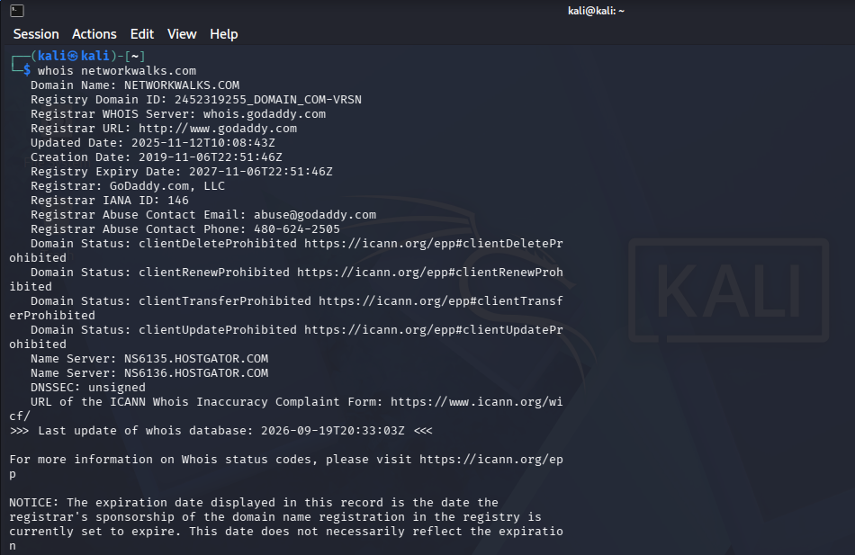
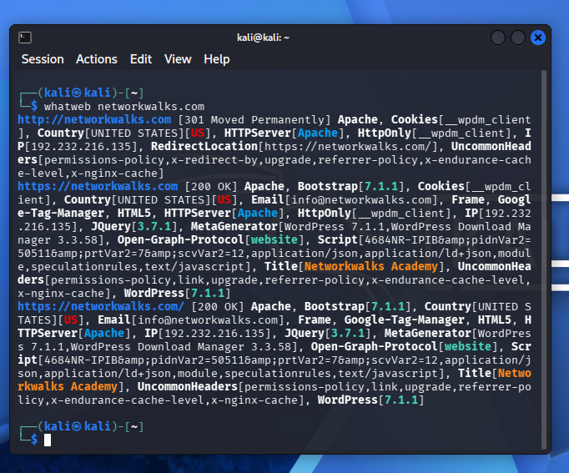
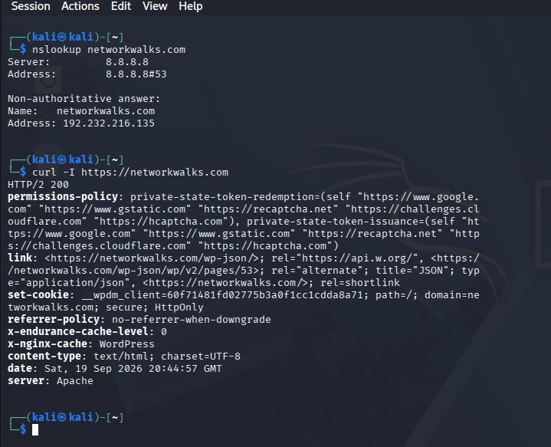
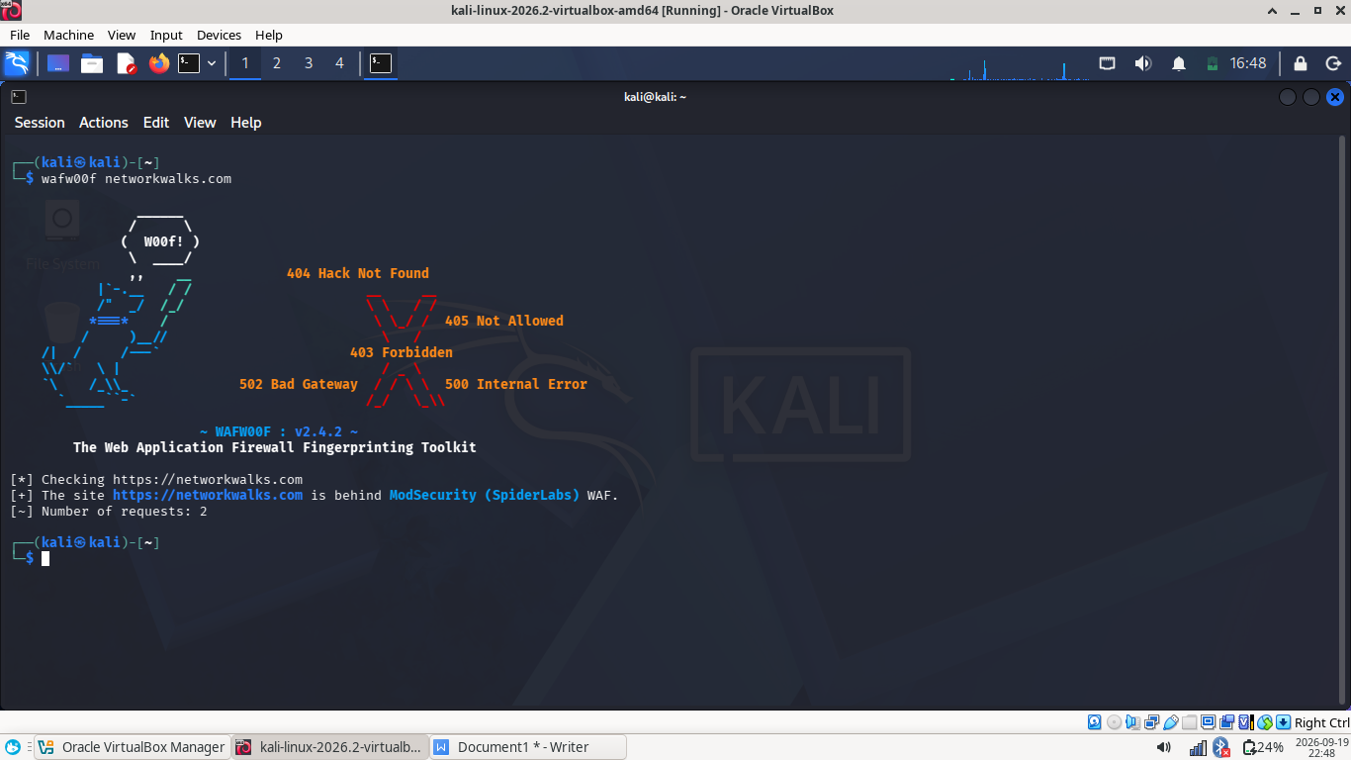
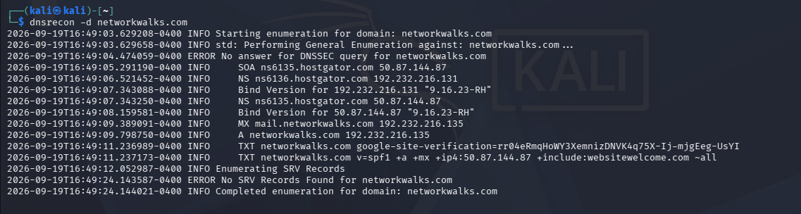
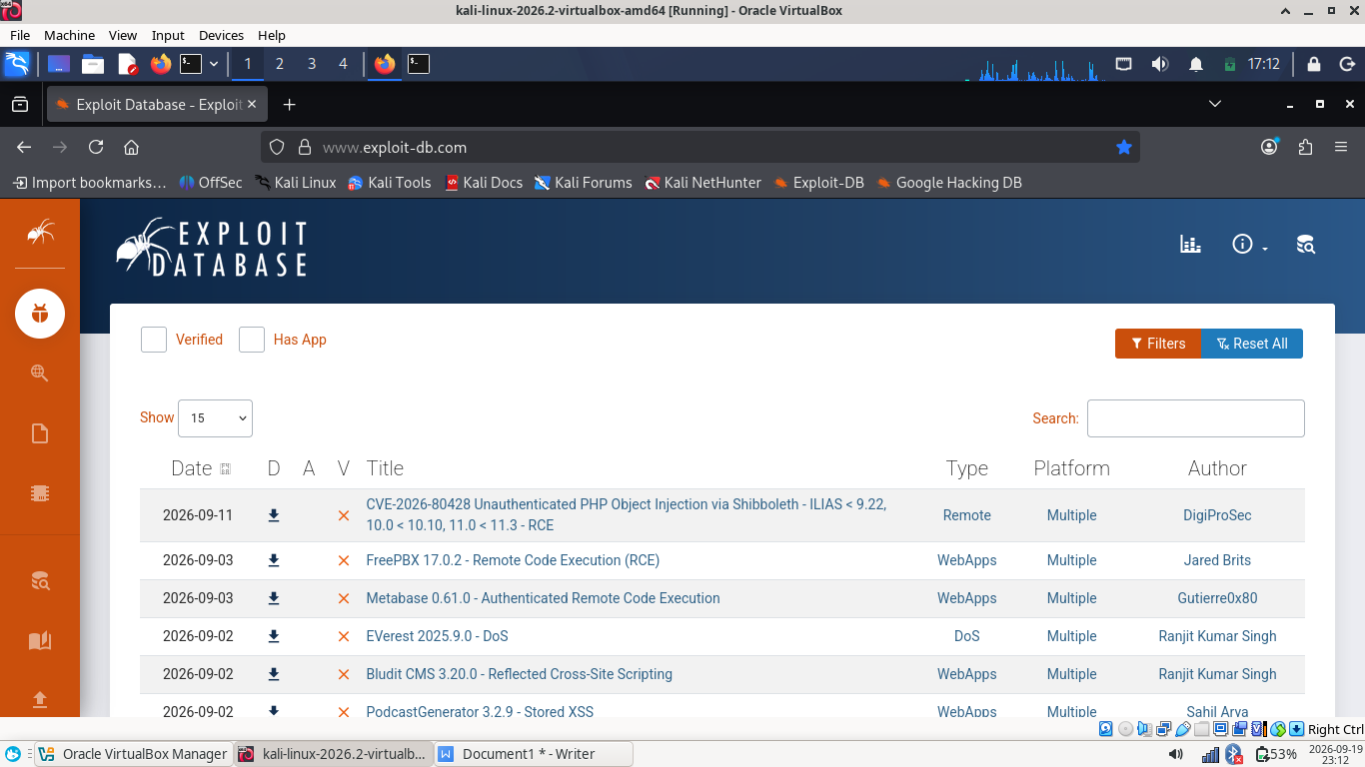
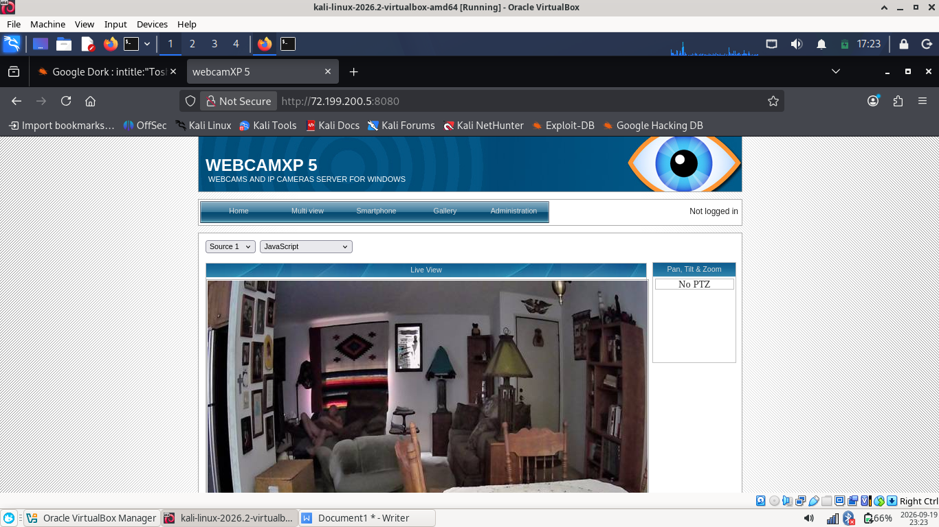
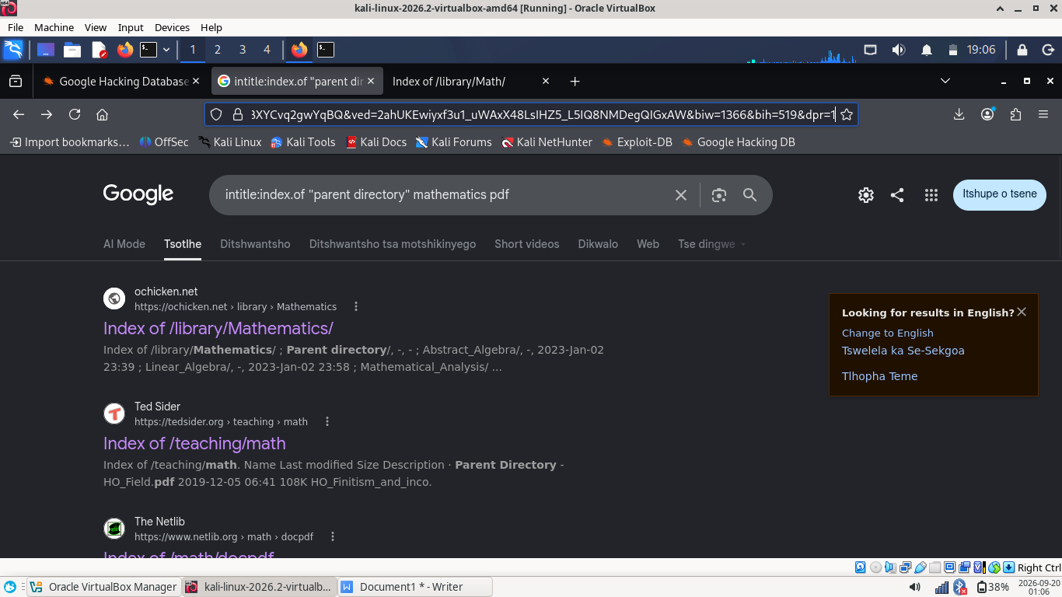
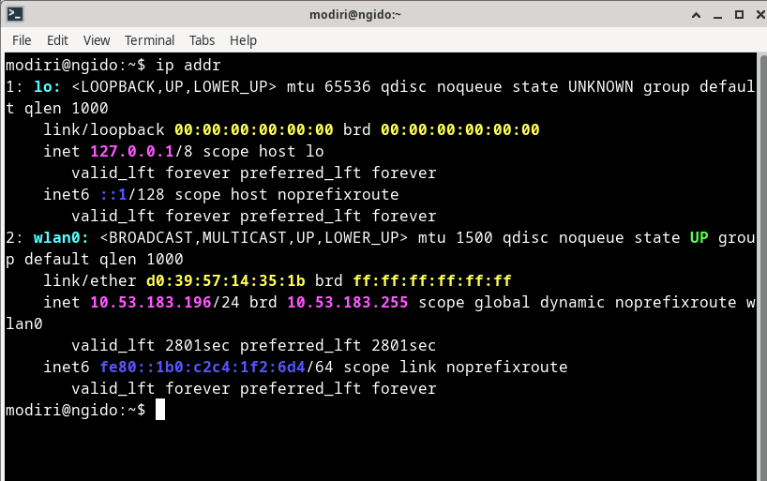
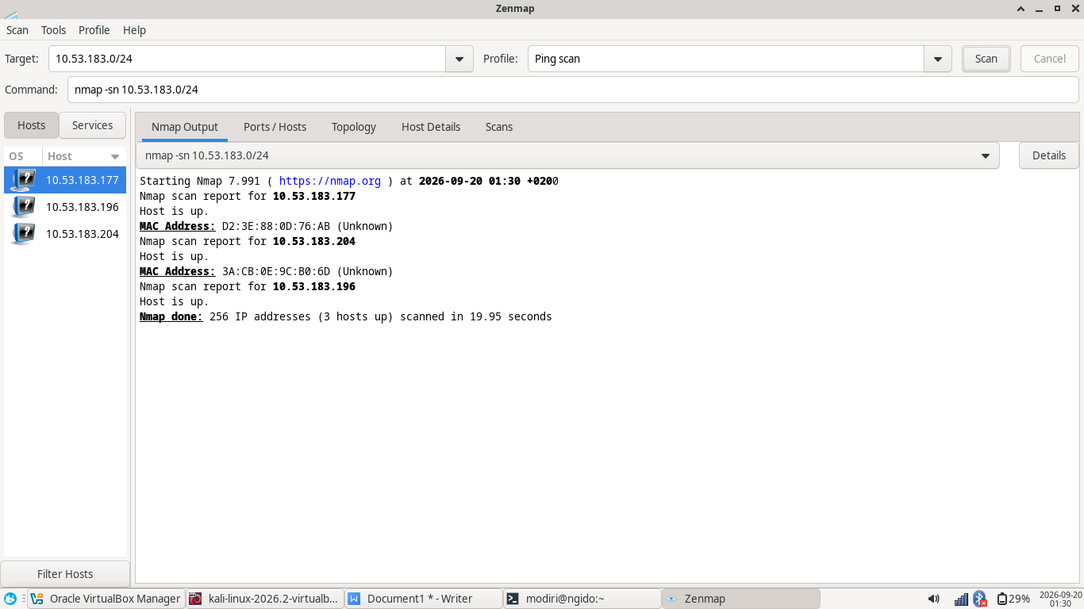

CONCLUSION
The Week 2 cybersecurity practical successfully demonstrated the reconnaissance and network-discovery stages of a penetration-testing methodology.
During the footprinting activity, multiple Kali Linux tools were used to collect publicly observable information about networkwalks.com. WHOIS provided domain-registration and name-server information. WhatWeb identified elements of the web technology stack. Nslookup resolved the domain to its public IP address. cURL provided visibility into HTTP response headers and application-related information. WAFW00F identified ModSecurity as the detected Web Application Firewall, while DNSRecon provided additional DNS infrastructure information.
The GHDB exercises demonstrated how search-engine operators can be used as reconnaissance mechanisms to identify publicly indexed resources. These exercises reinforced the importance of understanding what information an organization unintentionally exposes through public search engines and indexed resources.
The network-scanning exercise demonstrated how the same practical concepts can be applied to a local environment. Because the assessment workstation uses CachyOS rather than Windows, the Linux ip addr command was used to identify the local network configuration. The latest Nmap discovery scan identified two active hosts. The scan therefore recorded two hosts up, including the scanning workstation.
The difference between this result and earlier scans demonstrates an important practical characteristic of network reconnaissance: a network is a changing environment. Devices can connect and disconnect, particularly on wireless networks, meaning that host-discovery results represent a point-in-time observation.
Overall, the exercises demonstrated that significant information can be obtained before any exploitation is attempted. A penetration tester can build an initial understanding of a target through domain information, DNS records, application fingerprinting, HTTP responses, WAF identification, search-engine reconnaissance, and network host discovery.
The practical also reinforced the importance of accurate documentation. Security observations must be distinguished from confirmed vulnerabilities, and training examples must not be incorrectly presented as authorized findings.
All future testing should continue to operate within clearly defined authorization and scope

